The Business Honors Program is open to continuing California State University Fullerton students and to incoming transfers applying for the fall semester. To be considered for the Business Honors Program, you must submit the information indicated below. This information is also available at www.fullerton.edu/businesshonors. Acceptance into the Business Honors Program will be based on overall qualifications and a personal interview.

Eligibility (subject to change without notice)

To be eligible for consideration into the Business Honors Program, you must:
- Complete all required ‘core courses’ on the Business Honors Roadmap with a grade of ‘C’ or better prior to the Fall semester (see pages 3-4)
- Meet with the Business Advising office to confirm any required courses taken at a community college will transfer to CSUF
- Possess a minimum cumulative GPA of 3.25 (Sophomores) and 3.5 (Juniors) in all college coursework
- Demonstrate leadership, community service and/or creativity in your educational pursuits
- Provide two letters of reference
- Participate in a personal interview with members of Mihaylo College

Submit your application materials to: Business Honors Program
SGMH-3357 B
California State University Fullerton
Fullerton, CA 92834-6848
E-mail: mihaylohonors@fullerton.edu

Application Checklist
Applications are accepted until April 30 or when all spaces are filled –
Early submission is strongly recommended

_____ General information indicated on page 2
____ College coursework indicated on page 4
_____ Student essay as described on page 5
_____ Two letters of reference as described on page 5 (delivered via email)
_____ Academic transcripts – see details below
- Current CSUF students are not required to submit a transcript
- Students with junior level status due to AP work but with limited college courses completed should submit high school transcripts plus college transcripts to date

Please complete all sections. Please type or print clearly.

Name:

__________________________________________________CSUF CWID:____________________
Last First Middle

Address:  ______________________________________  ______________________________________ | Phone Numbers:  Home: ( _ _ _ ) _ _ _ - _ _ _ _  Cell: ( _ _ _ ) _ _ _ - _ _ _ _
E-Mail Address  CSUF email address:___________________________________  Personal email address:______________________ | Intended Concentration:  _______________  _______________ | Comments:
Post Secondary Schools Attended:  ________________________________________  ________________________________________ | Dates Attended:  __________________________  __________________________
Cumulative GPA for all college level coursework:  _____________________________ | Number of college units completed:  ________________

Mihaylo Business Honors Program Roadmap updated 2019 after
- All bold classes must be completed in the designated semester. Classes with * are not required for transfer.
- 4-year students may take up to 2 non-business honors sections of required classes over the 4-year program
- Transfer students may take 1 non-business honors section of required classes over the 2-year program
- Transfer students must complete the core business courses for Years 1 and 2 prior to joining the program
- Students may enroll in business honors courses with the cohort 1 year ahead if schedules and pre-reqs allow
- All students must take the business honors section of the capstone course (Mgmt 449) during their last semester
- Roadmap includes 24 units of optional University Honors courses required for the University Honors designation

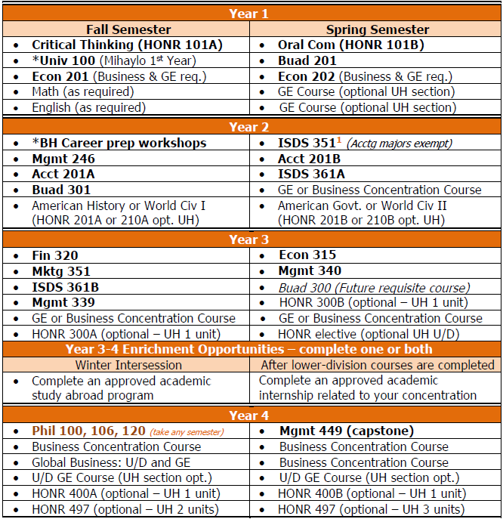

¹Transfer students subject to catalog year 2014-2015 and prior may satisfy ISDS 351 requirement by completing ISDS 265 equivalent course

GE = Lower division general education; U/D = Upper division; UH = University Honors req, optional for BH

Applicants to the Business Honors program must have completed all required ‘core’ courses indicated on the Business Honors Roadmap to be on track with the continuing Business Honors students. Use the worksheet below to indicate your status with respect to required business courses.

If you have taken any core courses at a community college and need assistance identifying corresponding courses, go to www.assist.org for a list of equivalent course names and numbers. Example: If you have taken Accounting 101AF (financial accounting) at Fullerton College, this transfers to Cal State Fullerton as Accounting 201A. Thus, in the column that is headed “Equivalent Course Name and #” you need to show the corresponding lower division course title and number that you took.

Course Title | Equivalent  Course Name & # | Already  Completed (Date) | In-Progress  (Date) | Plan to take when? | School at which the course was/will be taken
Economics 201
(Principles of Microeconomics)
Economics 202
(Principles of Macroeconomics)
BUAD 201
(Business Writing)
Mathematics 130
(Business Calculus)
= Incoming Sophomore | Incoming Sophomores must complete all (4) classes listed above before the Fall semester in order to be in the Business Honors Program
Accounting 201A
(Financial Accounting)
Accounting 201B
(Managerial Accounting)
ISDS 351 (Principles of Information Systems)
Management 246
(Legal Environment of Business)
ISDS 361A *  (Business Analytics I) |  |  |  |  | *
BUAD 301 * (Advanced Business Communication) |  |  |  |  | *
= Incoming Junior | Incoming Juniors must complete all (10) classes listed above before the Fall semester in order to be in the Business Honors Program

* ISDS 361A and BUAD 301 must be completed at CSUF or other CSU via Summer Extended Education program, before beginning the fall semester.

Student Essay

Please provide typed responses to the prompts below and send to the Business Honors Program with your application packet. Each response should be limited to no more than 150 words (300 words total.)

- Character
How do you see yourself contributing to a diverse university honors program?

- Statement of Your Educational and Career Goals
Describe how a specific idea, book, invention, or artwork has inspired your intellectual development.

Letters of Recommendation

Ask two individuals with knowledge of your character and/or work ethic to send the information below to the Business Honors Program via email at mihaylohonors@fullerton.edu. The recommendation should not exceed 150 words.

- List 3 words which best describe the applicant’s core attributes
- Describe at least one specific experience with the applicant which demonstrated one or more of the attributes indicated
- Indicate the title or position of the recommender
- Note how long the recommender has known the applicant

Acceptance Timeline

Qualified candidates will be contacted within two weeks of receiving the application to schedule a personal interview, if selected. Acceptance or declination of admission will be delivered within one week of the interview.

